1. Go to your Pavlovia Gitlab -> Projects, ‘New Project’, then follow the instructions to create a new project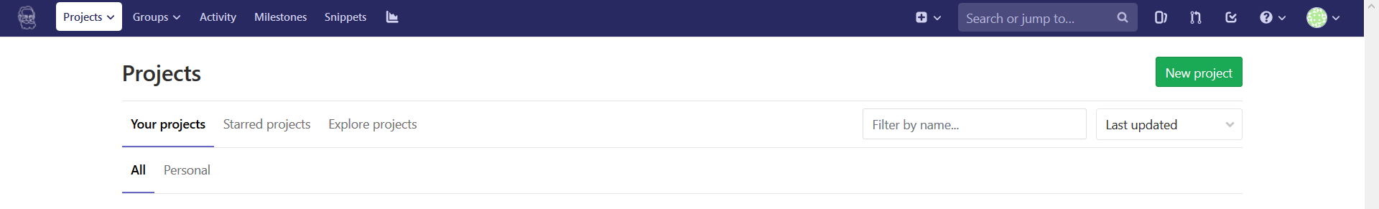
2. Clone the repository of this new project to Atom (see ‘1. Edit Locally’, steps 1-4)
3. You can directly create new files on Atom (screenshot) or just move files into the project’s local directory with the file explorer  
   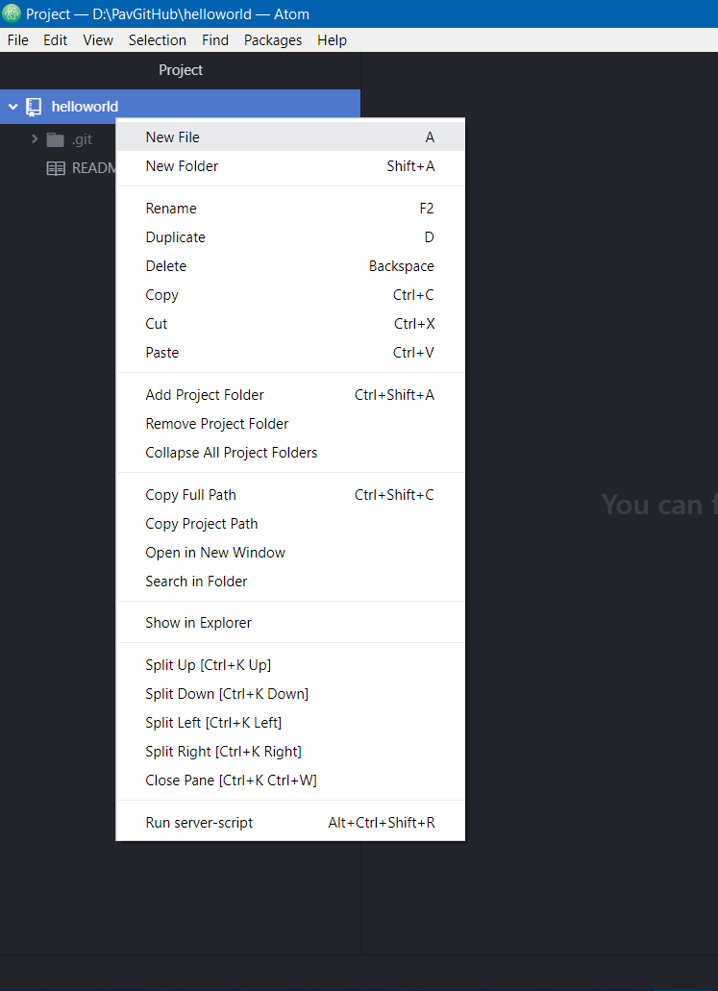

Note: Atom supports almost all programming languages, see <https://en.wikipedia.org/wiki/Atom_(text_editor)#Programming_language_support>

A new file is by default a .txt. It is critical to specify the file extension (e.g. .js for JavaScripts and .html for HTML) so that Atom knows which language you are writing in.

1. You can then build your website here (don’t ask me how!)

For the sake of testing it out, note that the only critical component is an ‘index.html’ file. Its function is to lay out everything you want to present on this webpage. Making use of different tags, you can directly write on the webpage, include snippets of code, or call an external file online or under the same root directory.

In this example, we made an index.html that sets the title of the webpage, writes some text and calls a JavaScript file called ‘thejs.js’:

<!doctype html>

<html>

<head>

<title>This is the title of the webpage!</title>

</head>

<body>

<p>This is an example paragraph. Anything in the <strong>body</strong> tag will appear on the page,

just like this <strong>p</strong> tag and its contents.

A javascript file will also be loaded and log 'reading' in the console.</p>

<script src = "./thejs.js"></script>

</body>

</html>

*thejs.js* does nothing but log a word in the browser’s console:

console.log('reading')

1. The locally set-up scripts can, of course, be run locally, see ‘2. Run Locally’, steps 6-7
2. To run these scripts online with Pavlovia, push the changes to GitLab, see ‘1. Edit Locally’, steps 6-9. After a successful push, everything magically appears on both GitLab and Pavlovia.